Route 53

1. Types of Routing Policies in Amazon Route 53 (Short):
1️⃣ Simple Routing
→ Routes traffic to a single resource.
2️⃣ Weighted Routing
→ Distributes traffic based on assigned percentage (example: 70% / 30%).
3️⃣ Latency Routing
→ Sends users to the region with lowest latency (fastest response).
4️⃣ Failover Routing
→ Switches traffic to backup resource if primary fails.
5️⃣ Geolocation Routing
→ Routes users based on their geographic location.
6️⃣ Geoproximity Routing
→ Routes traffic based on distance between users and resources (supports traffic bias).
7️⃣ Multivalue Answer Routing
→ Returns multiple healthy IP addresses (basic load balancing).

2. In Weighted Routing Policy if the weight is configured as zero for all servers how will R53 route the traffic?
If all records are configured with weight = 0 in Weighted Routing Policy, then:
✅ Route 53 treats all records equally and distributes traffic evenly across them.
⭐ Explanation:
- Weight normally decides traffic distribution.
- When all weights are zero, Route 53 ignores weight comparison.
- It behaves like equal distribution (similar to round robin).
⭐ Important Note (Interview Point):
👉 If at least one record has non-zero weight, then Route 53 will only route traffic to records with non-zero weight and ignore zero-weight records.

✅ Real-Time Interview Scenario – Weighted Routing (Zero Weight)
⭐ Scenario 1 – Testing New Server
- Server A → Weight 100 (Production)
- Server B → Weight 0 (Testing)
👉 Route 53 will send all traffic to Server A
👉 Server B receives no traffic (used for standby/testing).

⭐ Scenario 2 – All Servers Weight Zero
- Server A → Weight 0
- Server B → Weight 0
- Server C → Weight 0
👉 Route 53 will equally distribute traffic among A, B, and C.

⭐ Scenario 3 – Blue-Green Deployment
- Old App Server → Weight 100
- New App Server → Weight 0
👉 Initially, all users go to old server.
👉 Gradually increase new server weight (like 20, 50, 80) to shift traffic safely.

⭐ Interview Tip (Important)
👉 Zero weight means:
- Ignored if other records have non-zero weight
- Equal distribution if all records have zero weight

3. Types of Records in Amazon Route 53
1️⃣ A Record (Address Record)
→ Maps domain name to IPv4 address.
2️⃣ AAAA Record
→ Maps domain name to IPv6 address.
3️⃣ CNAME (Canonical Name Record)
→ Maps one domain name to another domain name.
4️⃣ Alias Record (AWS Special)
→ Maps domain to AWS resources like ELB, CloudFront, S3 (No extra cost, supports root domain).
5️⃣ MX Record (Mail Exchange)
→ Specifies mail servers for receiving emails.
6️⃣ TXT Record
→ Stores text information (mostly used for domain verification & security like SPF, DKIM).
7️⃣ NS Record (Name Server)
→ Defines authoritative name servers for the domain.
8️⃣ PTR Record
→ Used for reverse DNS lookup (IP to domain mapping).
9️⃣ SRV Record
→ Specifies services and their locations (used in advanced applications).

4. TTL (Time to Live) in Amazon Route 53
👉 TTL is the amount of time DNS resolvers cache a DNS record before requesting it again from Route 53.
⭐ Example:
- If TTL = 300 seconds (5 minutes)
→ DNS servers will store the record for 5 minutes before checking for updates.
⭐ Why TTL is Important:
- Low TTL
→ Faster DNS updates
→ More DNS queries
→ Useful during failover or migration
- High TTL
→ Better performance
→ Fewer DNS queries
→ Slower update propagation

✅ One-Line Interview Answer:
TTL in Route 53 defines how long DNS records are cached by resolvers before refreshing from the authoritative DNS server.

5. What is the diff between Public Hosted and Private Hosted Zone?
✅ Difference Between Public Hosted Zone and Private Hosted Zone (Route 53)
Feature | Public Hosted Zone | Private Hosted Zone
Access | Accessible from Internet (Public users) | Accessible only inside VPC (Internal users)
Usage | Used for public websites | Used for internal applications
DNS Resolution | Resolved through public DNS | Resolved only inside selected VPCs
Example | www.company.com accessible worldwide | internal.company.com accessible only inside company network

⭐ Public Hosted Zone
👉 Used when you want your domain accessible from the internet.
Example:
- Company website
- Public API
- Public application

⭐ Private Hosted Zone
👉 Used for internal AWS resources.
Example:
- Internal database server
- Internal microservices
- Backend applications

✅ Real-Time DevOps Example
✔ Public Hosted Zone → User accesses company website from anywhere.
✔ Private Hosted Zone → Application servers communicate internally using private DNS.

✅ One-Line Interview Answer
Public Hosted Zone resolves domain names over the internet, whereas Private Hosted Zone resolves domain names only within specified VPCs.

6. How to connect s3 hosted website and accessing the website via R53?
Connect S3 Hosted Website with Route 53

🔹 Step 1: Host Website in Amazon S3

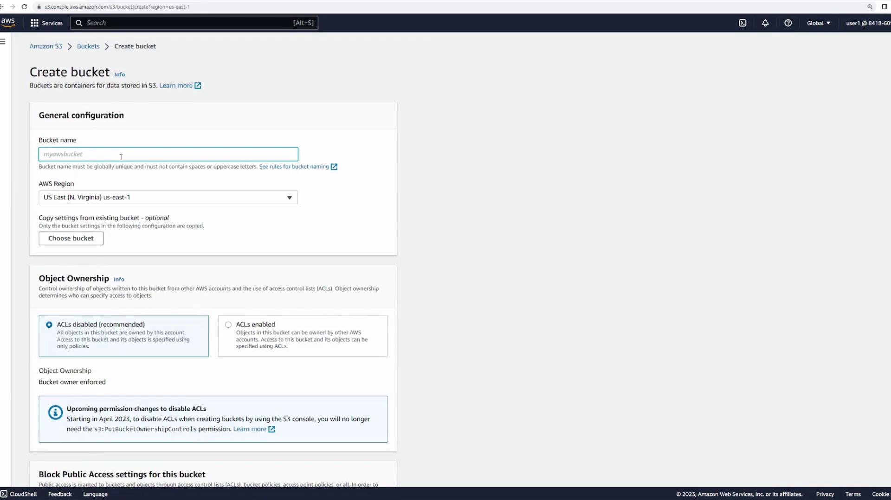
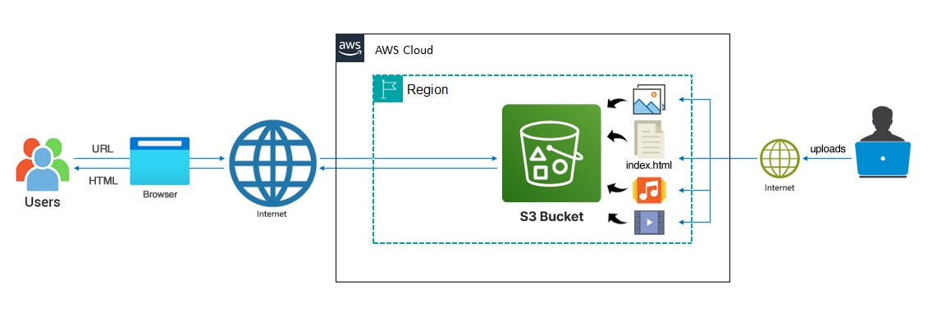
4
👉 Steps:
- Create an S3 bucket
  - Bucket name must match domain name
Example: example.com
- Upload website files
  - index.html
  - error.html (optional)
- Enable Static Website Hosting
  - Go to Properties → Static website hosting → Enable
- Make bucket public
  - Disable block public access
  - Add bucket policy for public read
- Copy S3 Website Endpoint URL

🔹 Step 2: Configure Route 53

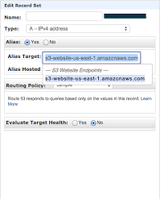
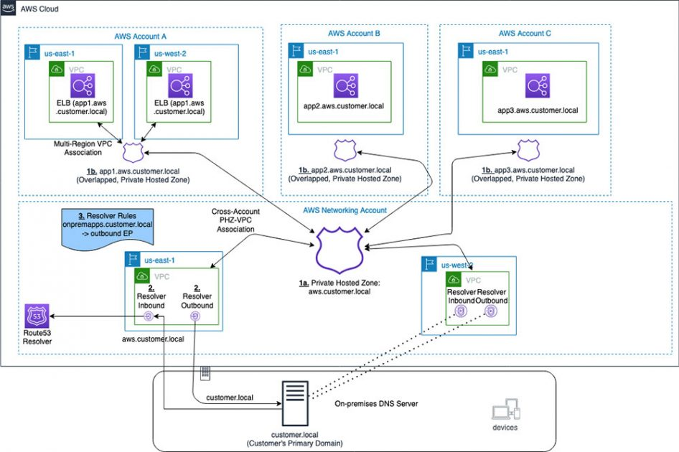
4
👉 Steps:
- Go to Route 53
- Create / Open Hosted Zone for your domain
- Create Record
  - Record Type → A Record
  - Enable Alias
  - Select S3 Website Endpoint
  - Choose your bucket
- Save record

🔹 Step 3: Access Website
👉 Now users can access website using:
www.example.com
Instead of S3 endpoint URL.

⭐ Real-Time Flow
User → Route 53 → S3 Static Website → Website Content

✅ Interview One-Line Answer
To connect S3 static website with Route 53, enable static website hosting in S3, then create an Alias A record in Route 53 pointing to the S3 website endpoint.

8. Host Two EC2 Instances with ALB and Access via Route 53
🔹 Step 1: Launch Two EC2 Instances
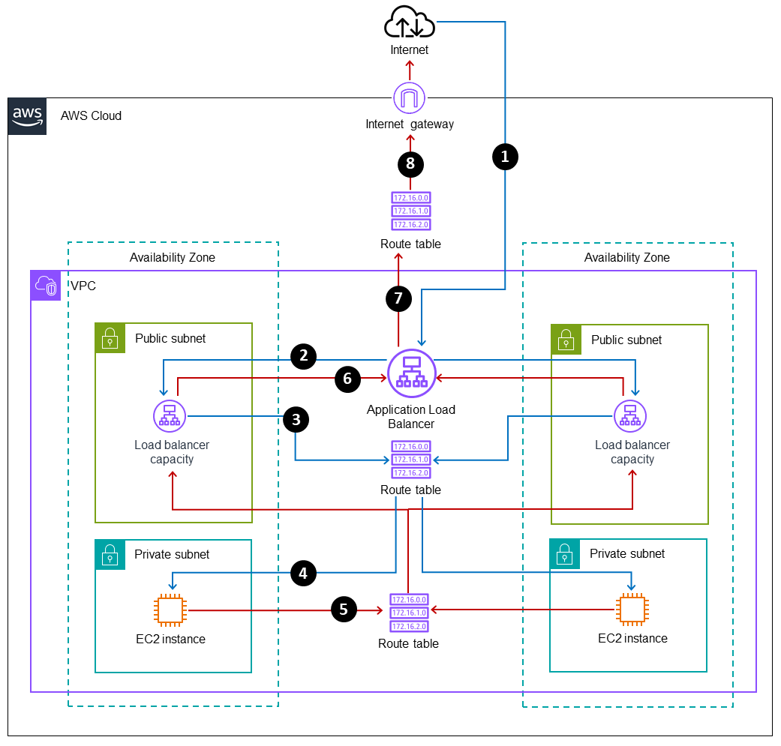
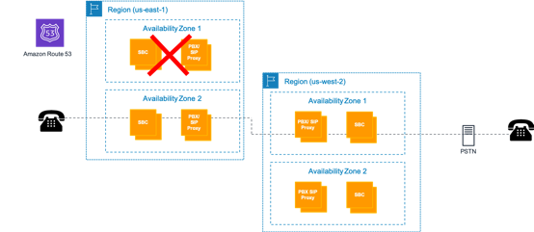
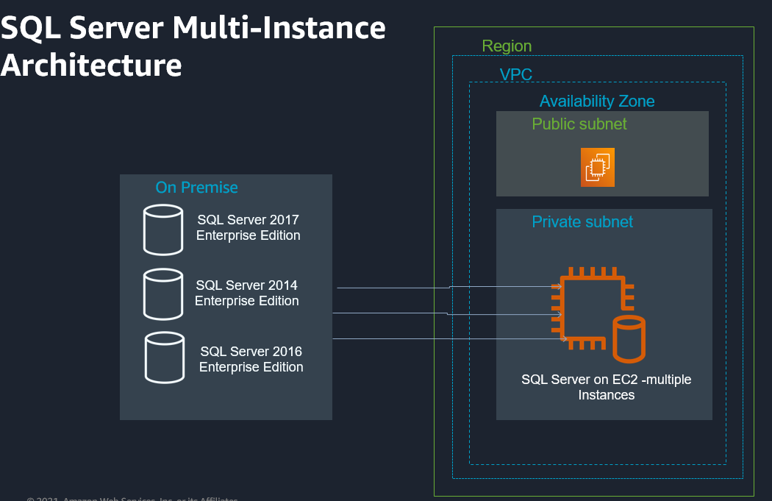
4
👉 Steps:
- Launch 2 EC2 instances
- Install web server (Apache / Nginx)
- Allow HTTP (Port 80) in Security Group
- Add sample web pages to verify load balancing
Example:
sudo yum install httpd -y
sudo systemctl start httpd

🔹 Step 2: Create Target Group
👉 Go to EC2 → Target Groups
- Select Target Type → Instances
- Protocol → HTTP
- Register both EC2 instances
- Configure health check

🔹 Step 3: Create Application Load Balancer (ALB)
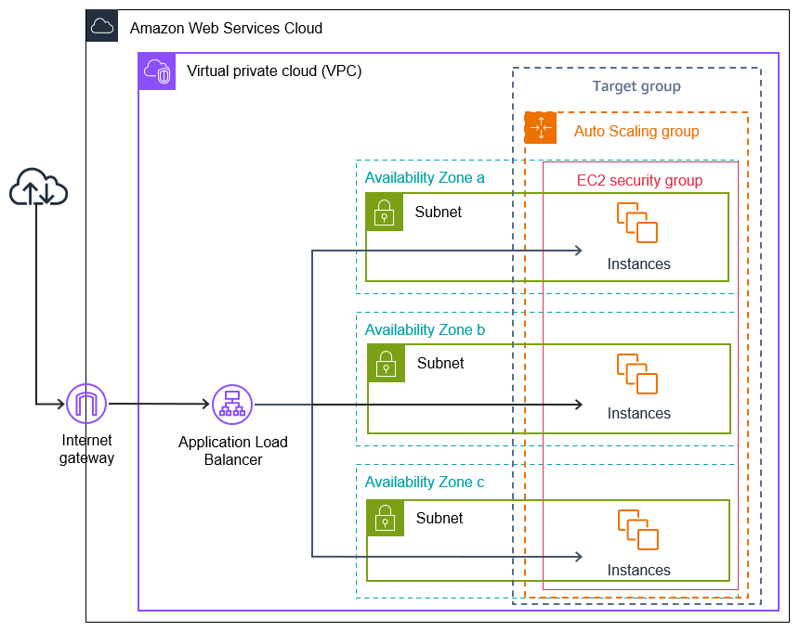
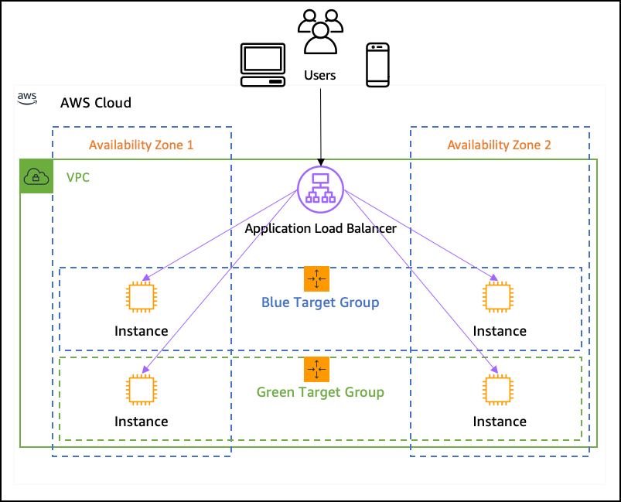

4
👉 Steps:
- Go to EC2 → Load Balancer → Create ALB
- Choose Internet-facing
- Select VPC and subnets
- Attach Security Group (Allow HTTP/HTTPS)
- Attach previously created Target Group
- Create ALB
👉 Copy ALB DNS Name

🔹 Step 4: Configure Route 53
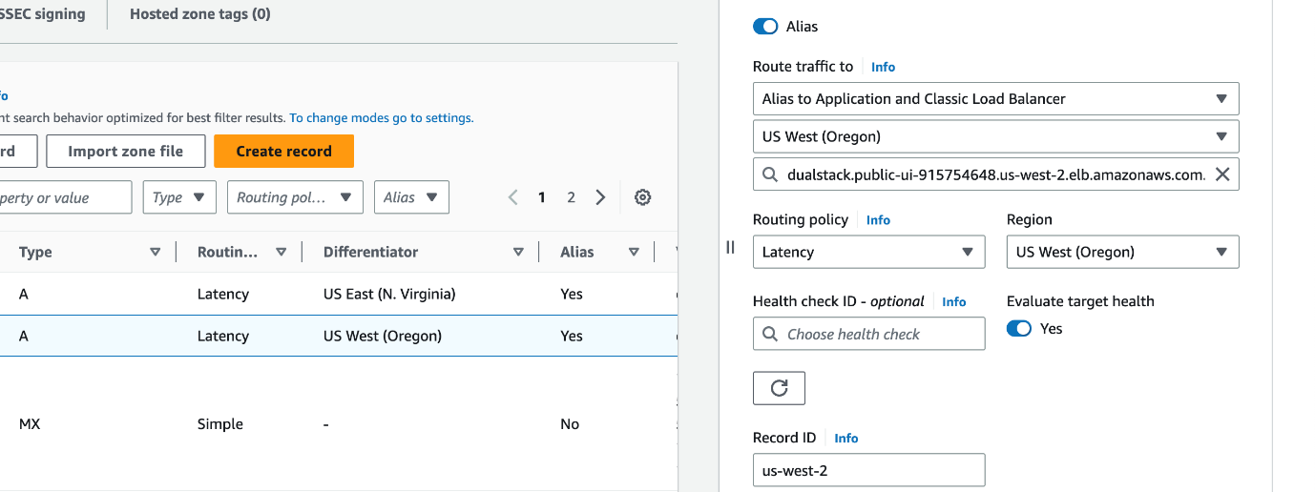
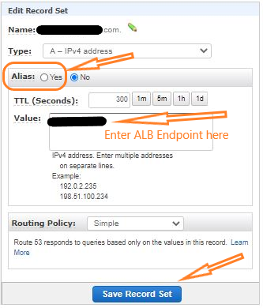
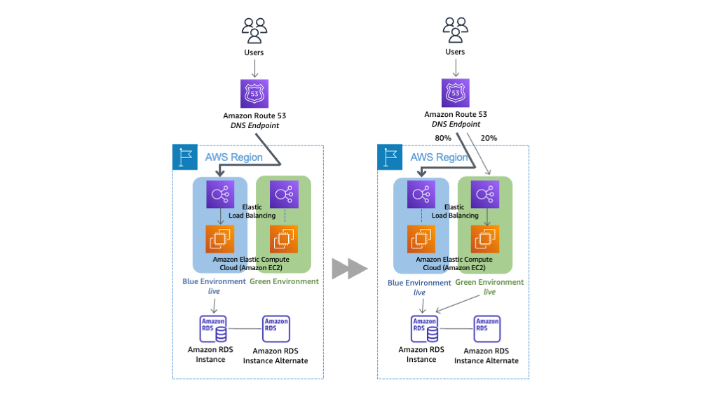
4
👉 Steps:
- Go to Route 53
- Open Hosted Zone
- Create Record
  - Type → A Record
  - Enable Alias
  - Select Application Load Balancer
  - Choose ALB DNS
- Save record

⭐ Final Traffic Flow
👉 User → Route 53 → ALB → EC2 Instances

✅ Real-Time Benefits
✔ Load balancing
✔ High availability
✔ Fault tolerance
✔ Scalability

✅ One-Line Interview Answer
Launch EC2 instances, attach them to a target group, create an ALB, and configure a Route 53 Alias A record pointing to the ALB DNS to access the application via domain name.

8. Difference Between Alias Record and CNAME Record (Route 53)
Feature | Alias Record | CNAME Record
AWS Specific | Yes (Route 53 feature) | No (Standard DNS record)
Maps To | AWS resources (ALB, CloudFront, S3, etc.) | Another domain name only
Root Domain Support | ✅ Yes (example.com) | ❌ No (only subdomains like www.example.com)
Cost | Free DNS queries | Normal DNS query charges
Performance | Faster (native AWS mapping) | Slightly slower (extra DNS lookup)

⭐ Alias Record
👉 Used to point domain directly to AWS resources
Example:
example.com → ALB / CloudFront / S3

⭐ CNAME Record
👉 Used to map one domain to another domain
Example:
www.example.com → example.com

✅ Important Interview Point
👉 Alias works at root domain but CNAME does not.

✅ One-Line Interview Answer
Alias record is an AWS-specific DNS record used to map domains directly to AWS resources and supports root domains, whereas CNAME maps one domain name to another and does not support root domains.

9. Deployment Strategies Used in AWS

1️⃣ In-Place Deployment (Rolling Update)
👉 Updates application on existing servers.
✔ Old version is replaced gradually
✔ No new infrastructure needed
❌ Small downtime possible

2️⃣ Blue-Green Deployment
👉 Two environments maintained:
- Blue → Current version
- Green → New version
✔ Traffic switched after testing
✔ Zero / minimal downtime
✔ Easy rollback

3️⃣ Canary Deployment
👉 New version released to small group of users first.
✔ Reduces risk
✔ Gradually increase traffic

4️⃣ Rolling Deployment
👉 Application updated server by server.
✔ No full downtime
✔ Safer than in-place deployment

5️⃣ A/B Testing Deployment
👉 Different versions shown to different users.
✔ Used for feature testing
✔ Helps compare performance

✅ One-Line Interview Answer
AWS supports deployment strategies like In-place, Blue-Green, Canary, Rolling, and A/B testing to release applications with minimal downtime and reduced risk.

